FY24 Learning Network of Minnesota Annual Report

# Executive Summary

There were two primary areas of focus for the Learning Network of Minnesota (LNM) during FY24:

* + **Strategic Planning Work**

A group of 12 members who met five times throughout the year to begin work on developing a strategic plan for the LNM. This group reviewed founding principles and existing practices for the Learning Network. The work focused on identifying strategic priorities to guide the Learning Network into the future. In this work, the seven priorities shown below rose to the top. The group identified the strategic priority focused on developing collaboration and partnerships as foundational to each of the other priorities.

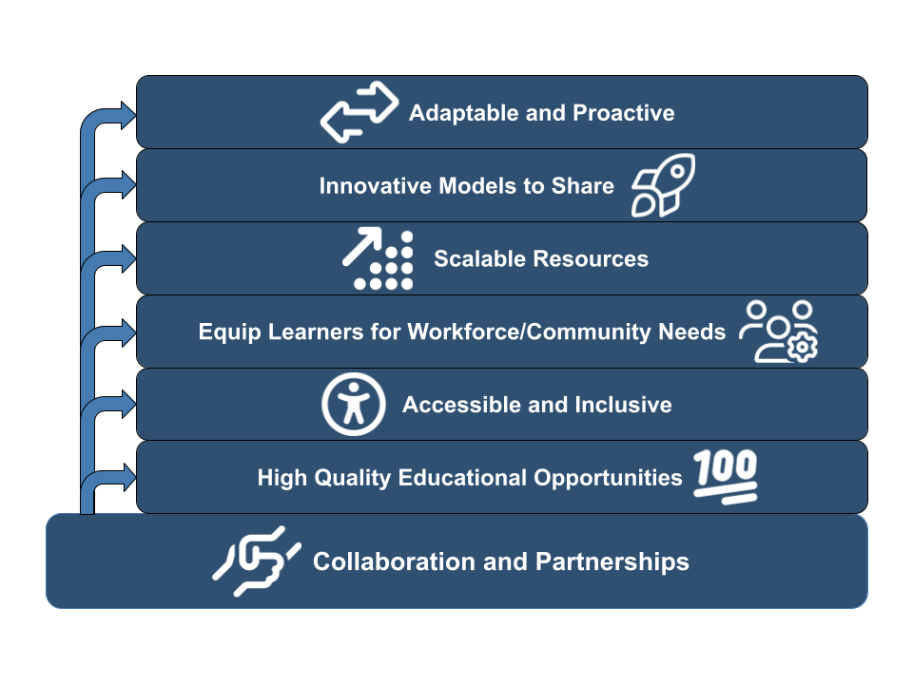

In terms of partnerships, the strategic planning group placed tremendous value on the collaboration between the University of Minnesota and the Minnesota State Colleges and Universities system that has resulted from LNM work. A continued priority to foster collaboration between those two systems is important. Other collaborations that the LNM has established and/or could promote include partnerships with:

* + - Educational Service Cooperatives
    - The MN Department of Employment and Economic Development (DEED), specifically for workforce development
    - The MN Office of Broadband Development, specifically to increase access to reliable high speed internet
    - PreK-12 Public Schools
    - Public Libraries
    - Tribal Nations
    - Local Non Profits

Additionally, a continued focus on partnerships between the six Learning Network of MN regions is important to the strategic planning group. Areas of emphasis for regional collaborations include sharing costs, people, training, and technology tools.

* + **The LNM as MN’s eduroam Support Organization**

In April, the Learning Network applied to become Minnesota’s eduroam Support Organization (eSO). Serving as an eSO for our state allows us to expand eduroam access to PreK-12 schools, libraries, museums, and to add eduroam hotspots throughout the state. The only way that organizations outside of higher education can become eduroam connector is through an eSO. Furthermore, there can only be one eSO in each state. By standing up this service, the LNM can

# LNM Services

**Zoom Rooms**

The LNM works with the Minnesota State and University of Minnesota systems to provide Zoom Room services at any of the campuses for distance learning support. All Zoom Room costs are paid by the Learning Network through proration of total licenses in use in each of the six regions. Furthermore, the LNM covers costs for H.323 connections to Zoom Rooms, which enable the use of existing Cisco Codecs and the legacy TMS scheduling. These technologies are currently being phased out to create efficiencies with new Zoom Room cloud services and hardware. The demand for Zoom Rooms continues to grow, as evidenced by a 26% increase in Zoom Room provisioning across the state over FY24 on top of 30% increase during FY23.

**Kaltura Media Space Application**

The LNM continues to support the provisioning of Kaltura Media Space cloud services to store and share video recordings. The University of Minnesota and Minnesota State Colleges and Universities entered into a new joint contract for Kaltura Media Space in 2022. The LNM continued to support this service by covering 25% of the total cost. We have completed the second year of a 3-year contract with the option to extend for 2 additional years.

**WAN Connectivity**

The LNM works with all member campuses, MN IT Services, and regional providers to build and maintain network infrastructure, connecting campuses to the statewide network. LNM is a cost sharing partner, collaborating with end users and service providers to prioritize infrastructure needs and utilize a shared network infrastructure throughout the state.

**Direct Support**

LNM regions provide support to member campuses in course video call scheduling, Zoom Room hardware purchasing, installation, and troubleshooting. The LNM assists campuses with room design and equipment selection to meet video, audio and content sharing needs in increasingly complex course delivery environments. The level of expectations for high quality video, audio, and media services for in-person, remote, synchronous, and asynchronous instruction continues to increase post-pandemic. The LNM works to share specific experiences and classroom design models between regions and member campuses.

# Regional Project Implementation

**CMDLN**

CMDLN invested $175k to support distance learning projects for the member campuses. Included in these projects were updated Zoom Room classrooms, increasing our active Zoom Room count by 9 (69 total). Other Grant funds were used to maintain quality remote experiences in the CMDLN supported rooms used for Zoom web conferencing (8 total).

**COMET**

*The COMET Board maintained existing systems and network connectivity for its member campuses*

*and began planning projects to complete in FY25 using funds from the current biennium. Project*

*proposals will be reviewed and approved this fall and will align with the current LNM strategic priorities.*

*Projects will support technology implementations to connect students to programs throughout the*

*region. COMET also expanded its total number of Zoom Rooms from 412 to 438, while also*

*reallocating some licenses in spaces that were not used to higher need areas.*

**METNET**

*The METNET Board maintained existing systems and network connectivity for its member campuses*

*and began planning projects to complete in FY25 using funds from the current biennium. Project*

*proposals will be reviewed and approved this fall and will align with the current LNM strategic priorities.*

*Projects will support technology implementations to connect students to programs throughout the*

*region. METNET also expanded its total number of Zoom Rooms from 406 to 519, while also*

*reallocating some licenses in spaces that were not used to higher need areas. This increase includes*

*rooms across member campuses as well as assumption of Medical School Rooms physically located at*

*the University of Minnesota Duluth campus.*

**NEAT**FY24 – NEAT invested $99k in equipment. Eight rooms were upgraded from Cisco equipment to HP/Poly to allow for uniform operation and expectations as Zoom Rooms. There were 29 new rooms added in NEAT Membership; the net gain is 16 new rooms as a whole due to some reductions at other locations.  
NEAT staff provided support with nearly all changes and was present at 9 locations throughout the year working with students, faculty, staff, maintenance, and vendors. Additional support was provided in the planning of offering programs to other locations outside of the LNM.

**NETS**

NETS completed a fiber redundancy project at Mstate Moorhead during FY24. NETS also completed its cisco to zoom room change over during this past year adding 6 new rooms while decommissioning 10 low use rooms, and updating 8 more. NETS has also provided funding ($30,000) to Minnesota State University Moorhead to assist with their Center for Business remodel in which all classrooms will have hyflex capabilities.

**SHOT**

SHOT’s focus during FY 24 was on supporting several key initiatives. First, SHOT supported the

implementation & sustainment of Zoom phone services for three of its five member

institutions—Minnesota West Community & Technical College, Ridgewater College and Southwest

Minnesota State University. The Zoom phone service replaced the previous Cisco IP voice service

operated by SHOT since 2002 for member institutions. Second, pursuant to ongoing long-range

planning, a new Instructional Technologist position was created and approved by the SHOT Board. As

of the end of the fiscal year, the position description was awaiting classification by Minnesota State.

Third, network bandwidth resiliency projects were initiated in conjunction with MN.IT for three (3)

member institution locations—Ridgewater, Willmar; Minnesota West, Canby; and the University of

Minnesota Southwest Research & Outreach Center campus outside of Lamberton. The Willmar site was completed during the fiscal year whereas the Canby project was still under development as of the end of the fiscal year. Notification was received from MN.IT that the Canby project was completed on September 18, 2024. Meanwhile, efforts to develop full resiliency for the Lamberton site were found to be cost prohibitive. However, a back-up service involving T-Mobile wireless services was implemented with the support of the University of Minnesota. Fourth, planning was conducted for utilization of remaining biennial funds. Identified projects include further hybrid classroom development at member institution campuses and equity and accessibility initiatives.

# LNM Regional Financial Reports

* + [Spreadsheet of Regional FY24 Financials](https://docs.google.com/spreadsheets/u/0/d/1efePyyg-z5TWCcYfheR4J6r14hQtK_53vGEgm2sdInc/edit)

1. **Current Goals/Objectives**

**LNM Objectives:**

* + *Develop a strategic plan to align and optimize regional and statewide LNM operations*
  + *Identify and analyze Zoom data in correlation with additional data points to inform practices in classroom design, equipment procurement, and best supporting multiple course delivery modalities*
  + *Develop a centralized LNM web presence representational of all regions and collaborative work across the network*
  + *Provide support to UMN and Minnesota State systems and campuses to maximize LNM services including video conferencing, media management, and scheduling systems*
  + *Support continued professional development efforts impacting distance learning including:*
    - *Use of Zoom-based Services*
    - *Digital Accessibility*
    - *Hybrid/Distance Academic and Student Support*
  + *Explore options for expanding Eduroam access to K-12 school districts, libraries, and museums throughout the state*
  + *Assess campus WAN bandwidth needs and identify cost-effective opportunities for adding resiliency*

# LNM Regional Membership

|  |  |
| --- | --- |
| **CMDLN** | **COMET** |
| * Alexandria Technical and Community College * Central Lakes College * Pine Technical and Community College * Ridgewater College * St. Cloud State University * St. Cloud Technical and Community College | * Minnesota State College Southeast * Minnesota State University Mankato * Riverland Community College * Rochester Community and Technical College * South Central Community College * University of MN–Rochester * Winona State University |
| **METNET** | **NEAT** |
| * Anoka Hennepin Technical College * Anoka Ramsey Community College * Century College * Dakota County Technical College * Hennepin Technical College * Inver Hills Community College * Metro State University * Minneapolis Community and Technical College * Normandale Community College * North Hennepin Community College * St. Paul College * University of MN–Twin Cities | * Grand Marais - CCHE * Grand Portage Community Center * Fond du Lac Tribal & Community College * Lake Superior College * Minnesota North College * NCROC - UofM Extension * UMN - College of Pharmacy * University of Minnesota - Duluth |
| **NETS** | **SHOT** |
| * Bemidji State University * Northwest Technical College * Northland Community and Technical College * Minnesota State Community and Technical College * Minnesota State University Moorhead * University of Minnesota Crookston | * Minnesota West Community & Technical College * Ridgewater College * Southwest Minnesota State University * University of Minnesota, Morris * University of Minnesota, Southwest Research and Outreach Center |